DETECTING PARKINSON’S DISEASE USING IBM WATSON MACHINE LEARNING MODEL

# 1.INTRODUCTION

## 1.1 OVERVIEW:

Parkinson's disease is a progressive nervous system disorder that affects movement. Symptoms start gradually, sometimes starting with a barely noticeable tremor in just one hand. Tremors are common, but the disorder also commonly causes stiffness or slowing of movement.

Although Parkinson's disease can't be cured, medications might significantly improve your symptoms. Occasionally, doctor may suggest surgery to regulate certain regions of brain and improve symptoms

COMMON SYMPTOMS

Muscle rigidity or stiffness of the limbs – most common in the arms, shoulders or neck

Gradual loss of spontaneous movement, which often leads to decreased mental skill or reaction time, voice changes, decreased facial expression, etc.

Gradual loss of automatic movement, which may lead to decreased blinking, decreased frequency of swallowing and drooling

A stooped, flexed posture with bending at the elbows, knees and hips

Unsteady walk or balance

Depression or dementia

## 1.2 Purpose:

More than 10 million people are living with Parkinson’s Disease worldwide, according to the Parkinson’s Foundation. The researchers found that the drawing speed was slower and the pen pressure is lower among Parkinson’s patients. So, App-based detection can be handy for many users for self diagnosing instead of going to hospital for detection.

# 2 LITERATURE SURVEY

## 2.1 Existing problem:

**Even though technology is developing fastly , there is no proper way to detect parkinson’s disease until its too late .The person has to go to the doctor for detection of the disease.But till then the situation may become worse for identifying the problem. So , an app based detection may helpful for the person for diagnosing themselves whether they are effected with parkinson’s disease or not.**

## 2.2 proposed solution:

An app based application which accurately detects the presence of Parkinson’s disease in an individual by taking the hand-drawn images of spirals and waves drawn by them as input is helpful for detecting parkinson’s disease before it becomes worse.This may helpful for a person for starting medication in proper time.

# 3 THEORITICAL ANALYSIS:

## 3.1 Block diagram:

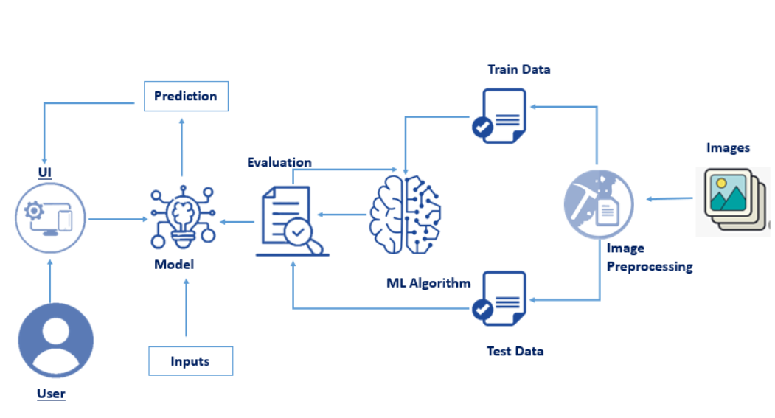

The user will give the input to the UI. The inputs given to the UI will be evaluated by the training given to the ML algorithm. Given images are preprocessed and are compared with the training and testing images in the algorithm and the output is predicted accordingly.

# 3.2 Hardware / Software designing:

We have firstly trained the model in the available python IDE(better to use spyder or pycharm) and then integrated with Flask in IBM

In training the model the important steps are :

1.Importing the necessary libraries required for image preprocessing

2. And then we have to load the dataset for training the model.

3.Split the dataset into train and test.

4.Train the model using Random Forest Regressor as it gives more accuracy for our model building.

5.Test the model and save it as pickle (.pkl) file

TEST RESULT:-

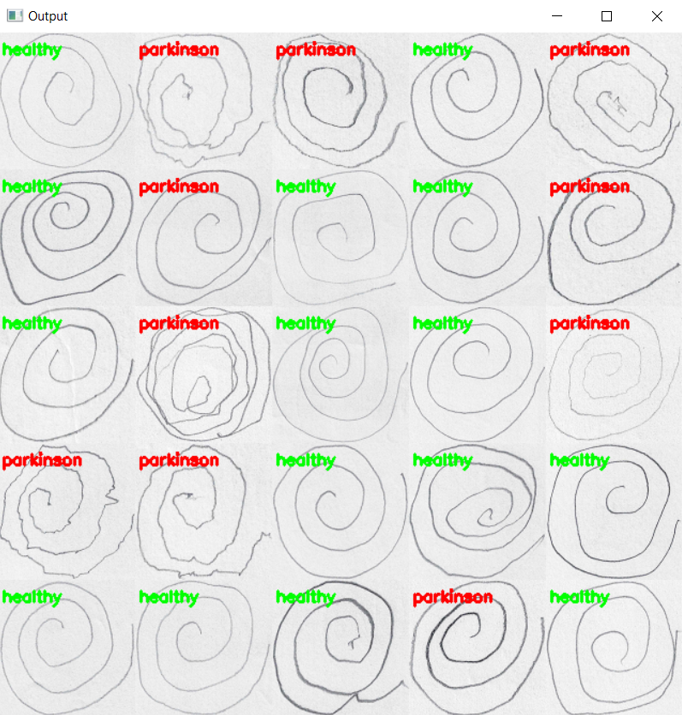

**Application Building:**

* Build the html pages for the web pages
* Build the css for styling
* Build the python code and connect the HTML and CSS files to the python code
* Save the python code
* Run the python code

**Running the Python code:**

* Open the anaconda prompt
* Navigate to the folder where your python code is saved
* Now type python file_name.py
* Python code will run and if there are no errors then the app.py will run in the port you have given in the code
* Now in the browser type localhost:port_number given in the code
* The web application for your trained model will open
* Now predict the output by giving new patient’s observation images

IBM deployment:

1.As we have saved the model in the folder.Now we have to deploy it in the IBM for getting an URL for our application instead of local port.

2.For that login into the IBM account and create an app in the Flask studio

3.Now connect to the IBM Watson using cf login in the prompt and push your app to IBM Watson using the command cf push.

4.If your app is successfully pushed then it starts running and an URL is generated for your app.

# 4 EXPERIMENTAL INVESTIGATIONS:

As our model’s accuracy is not 100% some results may be wrongly predicted. So, we have to analyse the model for its better accuracy.

We have to analyse the inputs given and the trained images and make required changes for better accuracy of the app.

# 5 FLOWCHART:

Import libraries

Loading the dataset

Splitting the data set

Training the model

Testing the model

Save the model

Building the html pages

And connecting with flask

Run the app in prompt

Output is displayed in

Local host

Deploy the app in ibm

# 6 RESULT:

.

**Home page:**

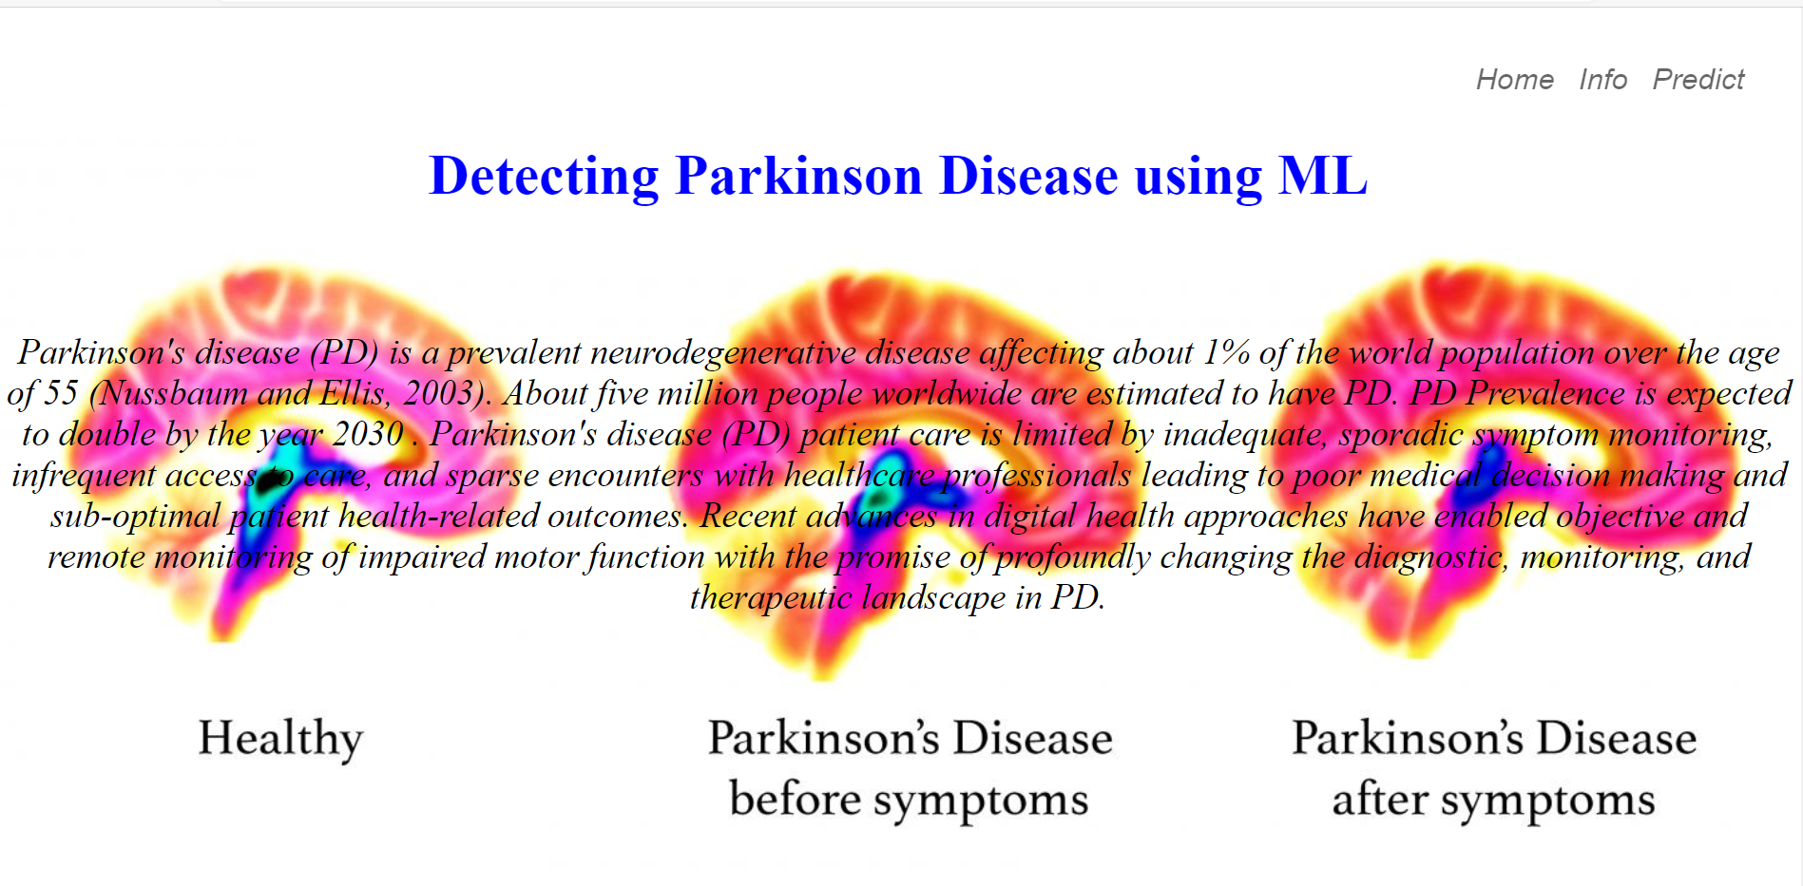

**Info page:**

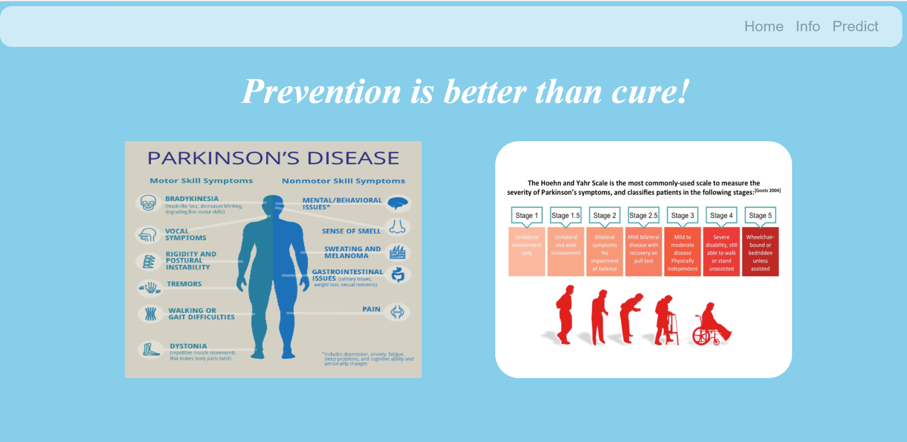

**Predict page:**

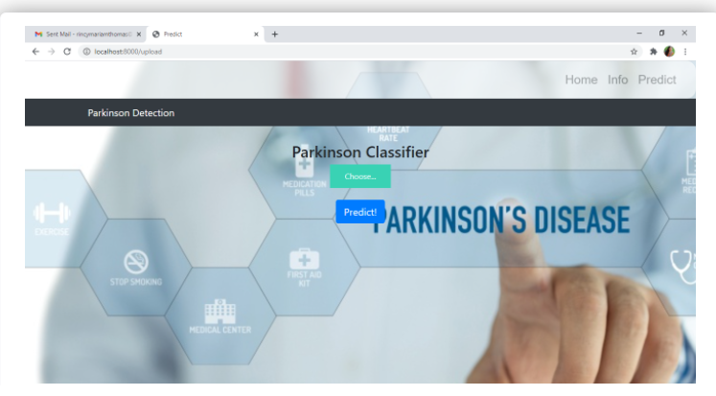

**Running the app:**

**1.** 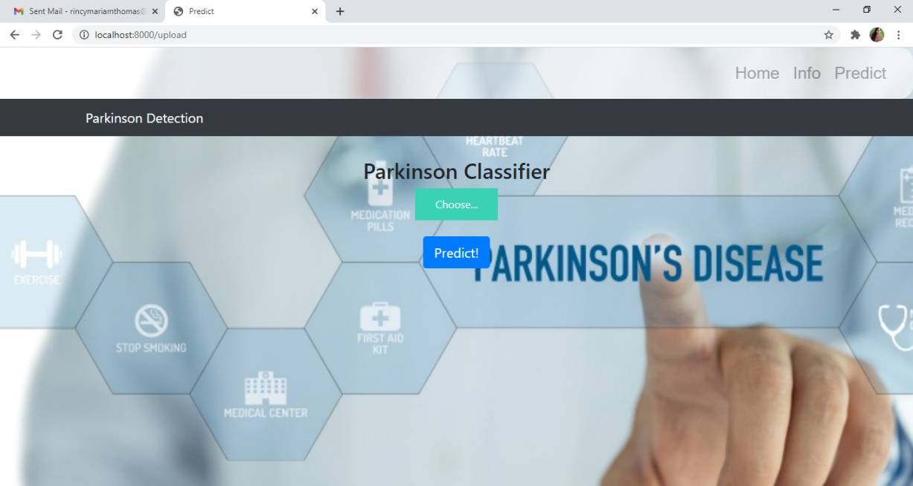

**2.** 4.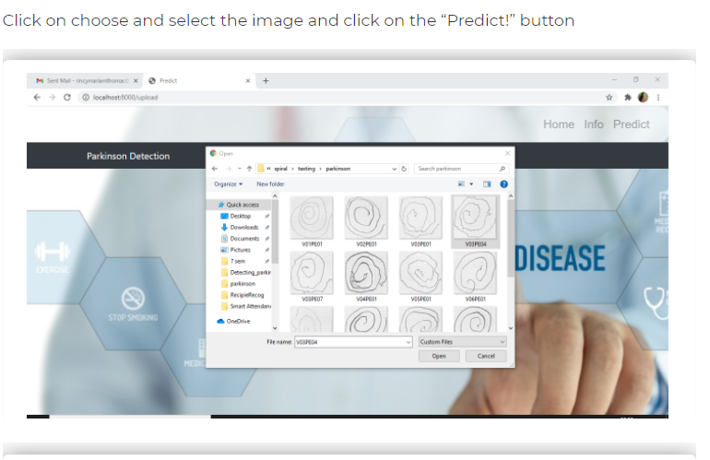

**3.** 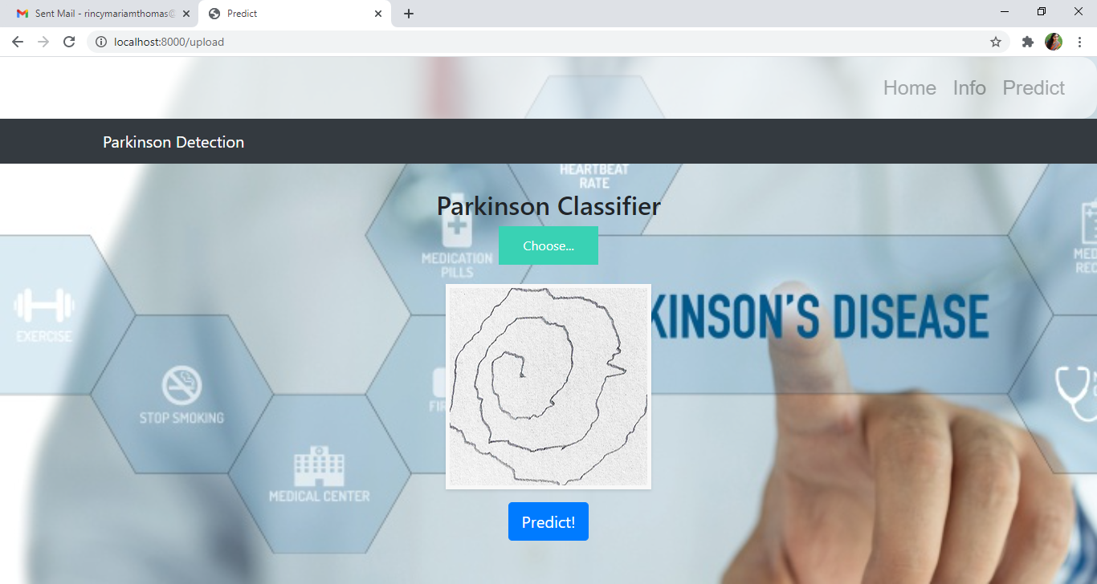

**4.** 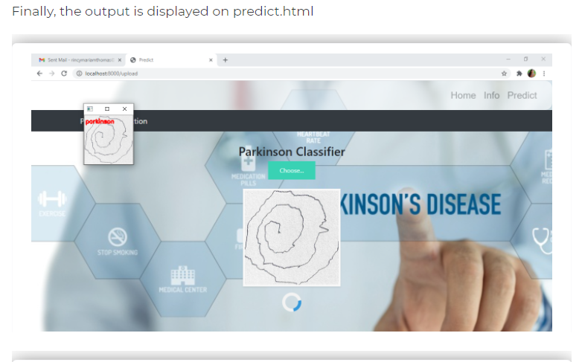

**5.** 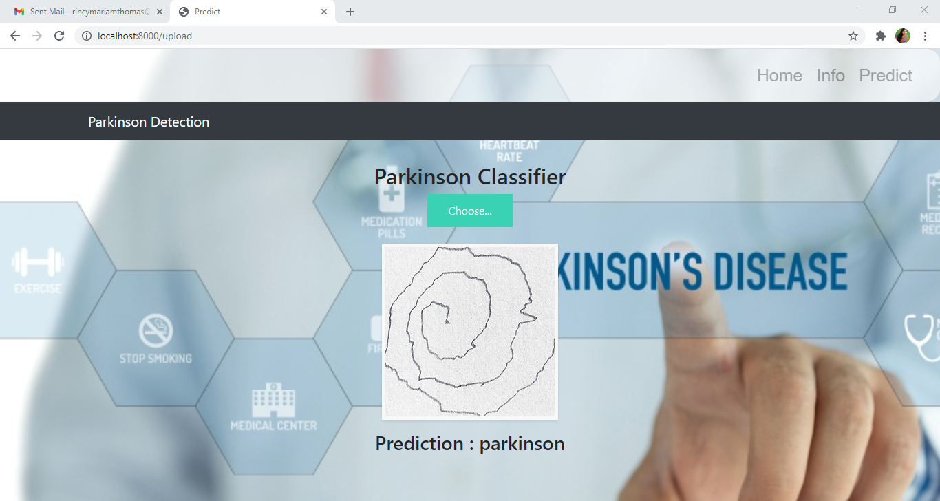

**Thus, we predict whether a person has parkinson’s disease or no**

# 7 ADVANTAGES & DISADVANTAGES:

## 7.1 ADVANTAGES:

1.User can easily understand the UI and diagnose themselves quickly according to the drawing speed and drawn images

2.Need not go to doctor for detecting the disease

3.As patient can know whether they have disease or not .,they can approach the doctor in time and can avoid severe effects of the disease.

4.Finally, we may reduce death rate caused by the parkinson’s disease.

## **DISADVANTAGES:**

1.As the accuracy is not 100% we may have some wrong results when the images matches both the features of healthy and parkinson’s effected person.

# APPLICATIONS:

It is applicable in medical field for early detection of parkinson’s disease

It is helpful for the treatment of the disease

# CONCLUSION :

We have build the App based application that detects the parkinson’s disease .

This may helpful for the early detection by the user itself without doctor’s help and can approach the doctor for the treatment.

# FUTURE SCOPE:

1.This app is helpful for researchers in knowing more about the parkinson’s disease.

2.If we improvise this model then this may helpful in treatment too.

3.AS we are busy in our day to day activities , this app helps you to recognise the problem.

4. As we already know that future is completely AI this helps doctors for the identification and treatment of the parkinson’s disease effected person.

# BIBILOGRAPHY:

Dataset and code reference given by -- <https://smartinternz.com/>

IBM Cloud -- <https://cloud.ibm.com/login>

HTML background images – <https://www.google.com/>

Theory reference – <https://www.google.com/>